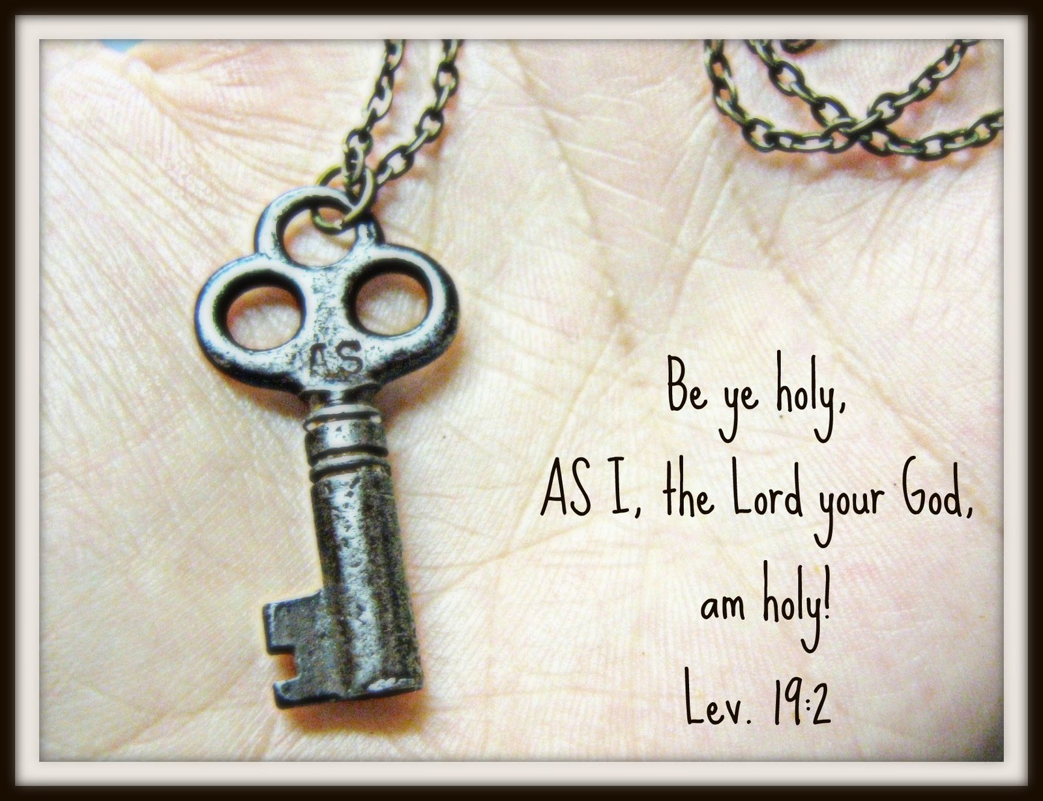
A Saint Like Me!

The Saints are examples of how God calls us to be holy. The Saints did many courageous, brave, and loving works in their lives.
Your task is to research a saint of your group’s choice. Guiding questions for research are:
- What is the selected Saint’s story?
- What are they a Patron Saint of?
- What makes them holy?
- How did they/do you think they prayed?
- What would they do in our world today to help?
- How are they similar to you and me?

Be creative! You can present your Saint in the forms of:
- A storyboard/comic strip
- A recorded movie
- A play
- A scrapbook
- A collage
- Any other ideas you may have that are run by/approved Mr. Thackeray first.
You will be presenting your finished products in class and will have three classes to work on them.

The final product is due: Friday September 15th
Presentations will begin on: Monday September 18th

