Subject/Class: Science | Title: Changing States of Matter: Solids to Liquids
Objectives/Expectations: (By the end of class, students will be able to….)
Main Objective: Understand how states of matter can change and why
- Know and understand the difference between each state of matter
- Know and understand how a solid can change to a liquid and how a liquid can change to a solid
- Know and understand why matter changes state
Introduction (20 mins)
Teacher Activity  - Ask students for the definitions of liquid, solid, and gas states of matter for review  - Provide students with visual of definitions on the board and ask them to get out their previous notes/handouts on the subject  - Activity: Have images on the smart board for students to sort into the correct categories. Also have the images printed for students to label at their desk.  - Explain to the class that objects in one state of matter can change to become another state of matter when affected by heating or cooling. Today’s focus will be on solids changing to liquids and liquids changing to solids. | Student Activity  - Provide definitions of liquid, solid, and gas – review previous handouts  - Activity: Complete handout while following the matching activity on the board. Participate to help the class determine which object is in which state  - See handout attachment below

Lesson Development (30 mins)
Teacher Activity  - (10 min) Split the class into groups and give each group ice cubes. Give students a couple minutes to observe what happens to an ice cube in their hand. Ask the following questions:  - What state is an ice cube in? What happens when an ice cube melts? Is it still a solid?  - What state is water in? What happens when you freeze water? Is it still a liquid?  - (20 min) Students will work individually, in pairs, or with the teacher via the smart board on the following BBC website activity which shows more examples of solids changing to liquids. It includes auditory options. http://www.bbc.co.uk/schools/scienceclips/ages/8_9/solid_liquids_fs.shtml | Student Activity  - Work together to determine the properties of the water and ice cubes. Answer and discuss the questions posed by the teacher.  - Complete the online activity, following the steps and answering the questions for heating and cooling different materials.

Closure/Reflection (20 mins)
Teacher Activity  - Do two examples from the BBC activity together. Make note to students of the different temperatures used to turn different solids into liquids – ice turns to water at much lower temperatures than aluminum. Then, complete the Quiz portion together.  - Ask students for other examples of things that could be changed into a liquid from solid form and how. | Student Activity  - Answer teacher questions based on the activity completed. Help the class complete the quiz. Ask any questions.

Assessment (Each Student will be assessed on…)
- Following steps of online activity to ensure understanding
- Answering questions, asking questions, and providing further examples of how solids can turn into liquids to show their understanding
Extension (If there is extra time at the end of class or used for next class)
- Do the BBC activity for changing liquids to gases
http://www.bbc.co.uk/schools/scienceclips/ages/9_10/gases_fs.shtml
Other/Tools/Materials
- Handouts for introductory activity for students to write which is a solid, liquid, and gas (see below)
- Ice cubes
- Computers/iPads for students

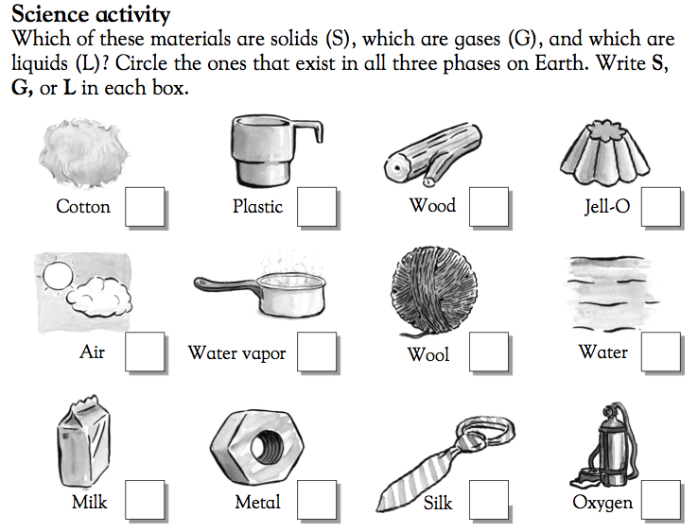
Source: http://www.greatschools.org/worksheets-activities/6261-solids-liquids-and-gases.gs

